S5. Data Extraction Form
The dataset extracted for synthesis/meta-analysis was stored in the Framework_elements sheet of the HAIL_Publica_Open_EXCEL_Data.xlsx file. The ABCE_CRI_KW and ABCE_Result sheets respectively contain the ABCE criteria keywords and their corresponding analysis outputs. Likewise, the UNESCO_CRI_KW and UNESCO_Result sheets present the UNESCO criteria keywords and results. The ABCE-UNESCO sheet consolidates comparative data between the two frameworks and incorporates adjustments based on expert qualitative evaluation.
The first screening criterion was topic relevance, with records documented in the 1st Screening: Topic relevance field of the 395Papers sheet in S4 Supplementary File. The second screening applied a scope check, recorded in the 2nd Screening: Scope check field. The third screening consisted of a final content check for specific components, with logs stored in the 3rd Screening: Final content check_Specific components field. The Reason field documents the justification for each screening decision.

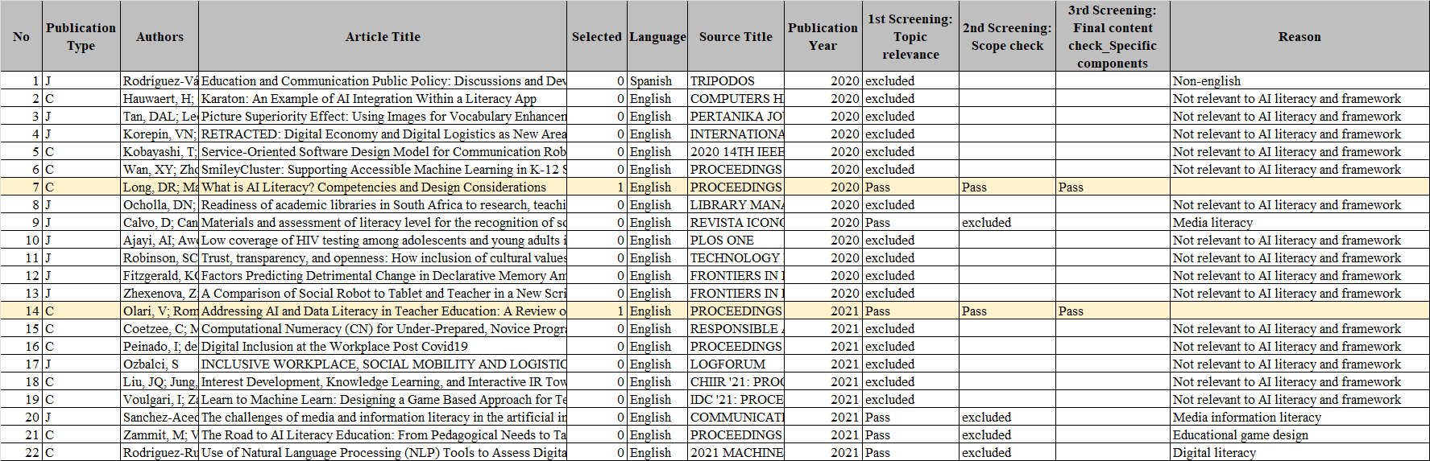
Figure S5.1: 395Papers sheet in S4 Supplementary File

The final results were recorded in the ABCE-UNESCO sheet and submitted as Supplementary File S6. All related materials, including S4 and S6, are consolidated in the HAIL_Publica_Open_EXCEL_Data.xlsx file and made publicly available via GitHub. By adjusting the file path specified in the released source code, readers can directly reproduce the analysis and access the corresponding results.
The 41Papers sheet includes the Article Number and Article Title for the 41 screened studies, as well as the Framework Elements extracted through expert qualitative evaluation. The final No field denotes the corresponding index aligned with the No field in the 395Papers sheet.

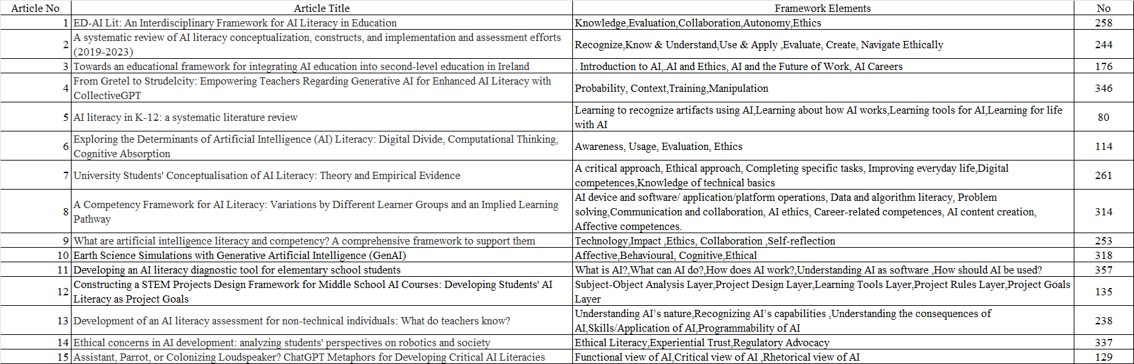
Figure S5.2: 41Papers sheet in S4 Supplementary File

The Meta sheet in Supplementary File S7 summarizes the results of the ABCE and UNESCO analyses, including the number of keywords identified for each category, the number of duplicates removed, and the final number of keywords retained. Remains represents the number of keywords retained after processing that were ultimately included in the final table.

Figure S5.3: Evidence table includes information for verification

The ABCE_CRI_KW sheet lists the criteria keywords extracted from ABCE-related studies through expert qualitative evaluation.

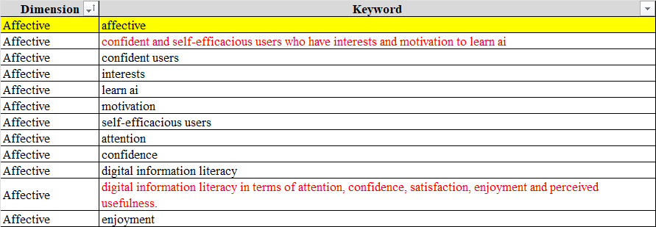
Figure S5.4: Criteria keywords extracted based on expert qualitative evaluation

In the ABCE_Result sheet, the Paper No. field corresponds to the Article Number, and the Keyword field contains the 272 extracted keywords. The fields Sim_max_Affective, Sim_max_Behavioural, Sim_max_Cognitive, and Sim_max_Ethical present the maximum cosine similarity scores between each keyword and the criteria keywords for the respective categories. The BestSim_max field indicates the highest similarity value among the four categories, and the BestCategory_max field identifies the corresponding optimal category.

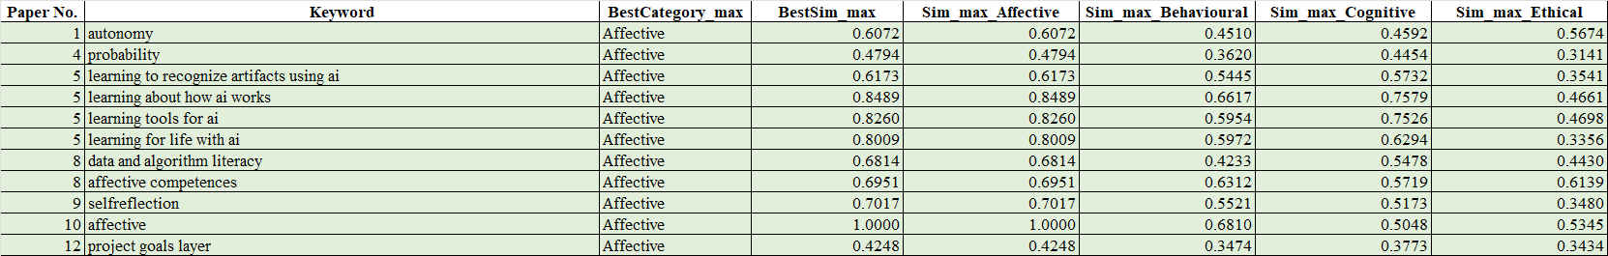
Figure S5.5: ABCE analysis results

The UNESCO_CRI_KW sheet lists the criteria keywords extracted from UNESCO-related studies based on expert qualitative evaluation. The UNESCO_Result sheet records the calculated results, following the same calculation procedure used for the ABCE_Result sheet.

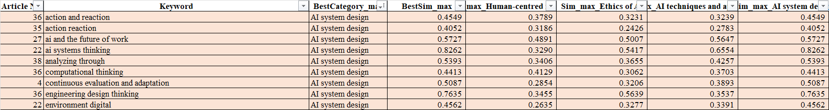
Figure S5.6: UNESCO analysis results

The ABCE-UNESCO sheet integrates the ABCE and UNESCO classification results and includes adjustments derived from expert qualitative evaluation.

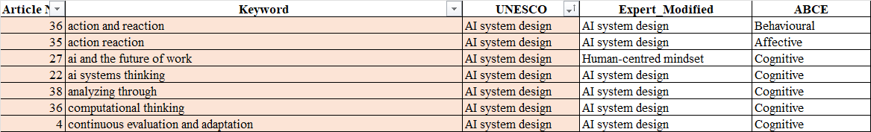
Figure S5.7: Final results modified based on expert qualitative evaluation

